**HOMEWORK 7**

1a) creating AWS windows 2019 EC2 instance

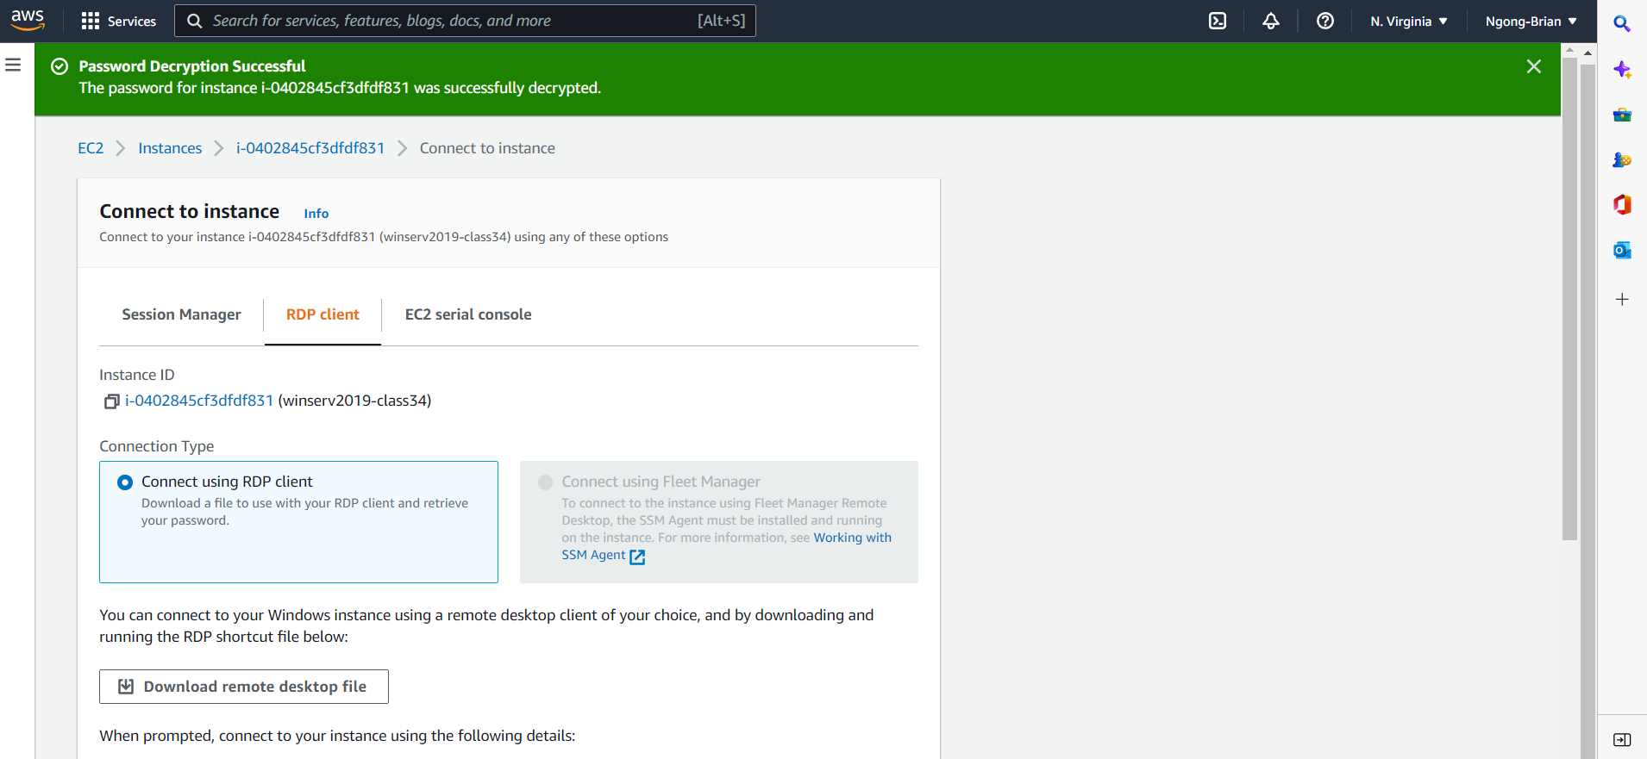

a) Create and share a folder called class34share on win10pro

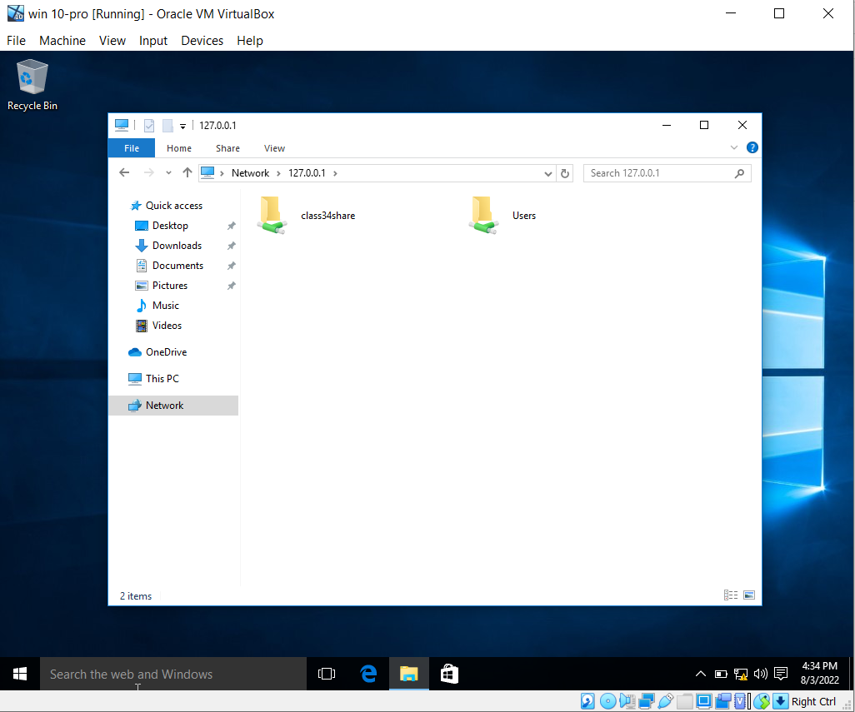

b) Map a drive letter M from your laptop to the share on your win10pro VM

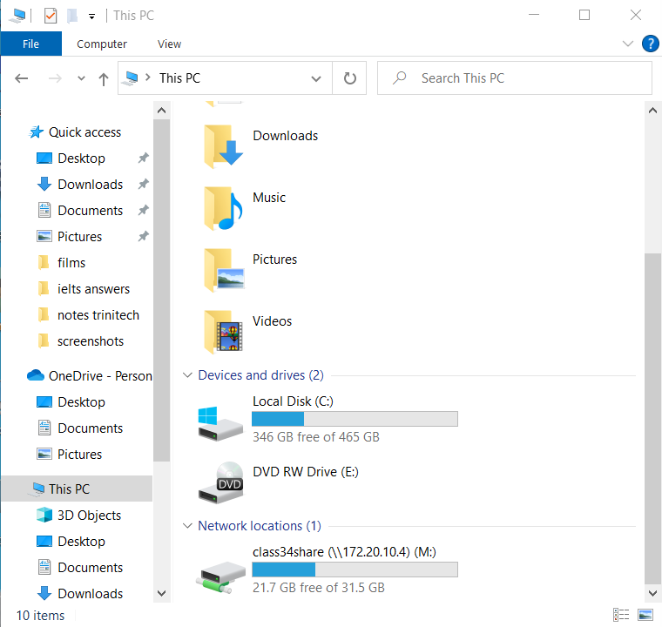

2) windows server 2019

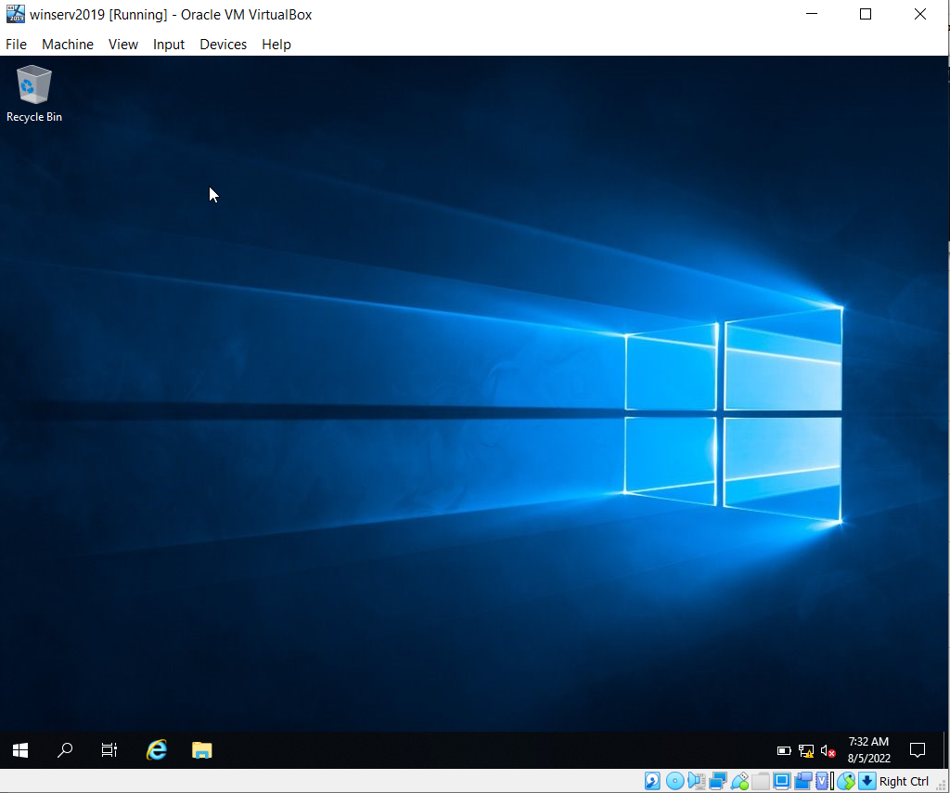

3) windows server 2008

